SRM INSTITUTE OF SCIENCE AND TECHNOLOGY FACULTY OF ENGINEERING AND TECHNOLOGY DEPARTMENT OF CHEMISTRY

*18CYB101J-CHEMISTRY* PART-B

3 Mark

Module-1

# What is the Physical significance of Wave function?

The wave function ψ associated with a moving particle is not an observable quantity and does not have any direct physical meaning. It is a complex quantity. The complex wave function can be represented as ψ(*x, y, z, t*) = *a* + i*b* and its complex conjugate as ψ*(*x, y, z, t*) = *a* – i*b*.

# Explain the term wave function?

A **wave function** is defined to be a **function** describing the probability of a particle's quantum state as a **function** of position, momentum, time, and/or spin. **Wave functions** are commonly denoted by the variable Ψ. A **wave function** may be used to describe the probability of finding an electron within a matter **wave**.

# Define Eigen value and Eigen function?

A mathematical operation on a function if it gives any constant multiplied with the function itself then, the function is eigen function for corresponding operator and the constant value obtained is called eigen value. For example energy, you operate on the wavefunction with the [quantum](http://hyperphysics.phy-astr.gsu.edu/hbase/quantum/qmoper.html#c1) [mechanical operato](http://hyperphysics.phy-astr.gsu.edu/hbase/quantum/qmoper.html#c1)r associated with that parameter. The operator associated with energy is the [Hamiltonian](http://hyperphysics.phy-astr.gsu.edu/hbase/quantum/hamil.html#c1), and the operation on the wavefunction is the [Schrodinger equation](http://hyperphysics.phy-astr.gsu.edu/hbase/quantum/scheq.html#c1).



# Give any two applications of Schrodinger wave equation.

Schrodinger [equation gives us a detailed account of the form of the wave functions](https://byjus.com/physics/wave-function/) or probability waves that control the motion of some smaller particles. The equation also describes how these waves are influenced by external factors. Moreover, the equation makes use of the energy

conservation concept that offers details about the behaviour of an electron that is attached to the nucleus.

Besides, by calculating the Schrödinger equation we obtain Ψ and Ψ2, which helps us determine the quantum numbers as well as the orientations and the shape of orbitals where electrons are found in a molecule or an atom.

# Write down the one-dimensional Schrodinger time independent wave equation and the same for a free particle.

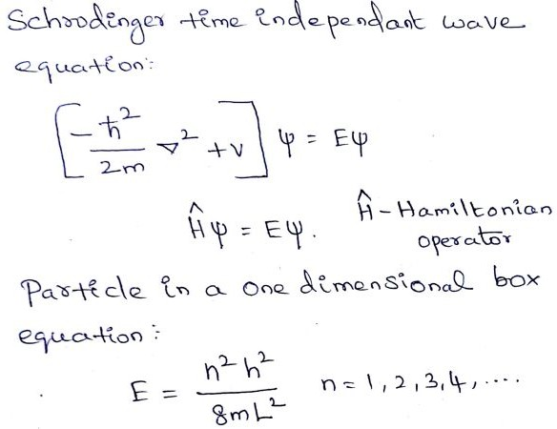

1. **What is the Normalization process and give a normalized wave function for an electron in one dimensional potential well of length “a” meter.**

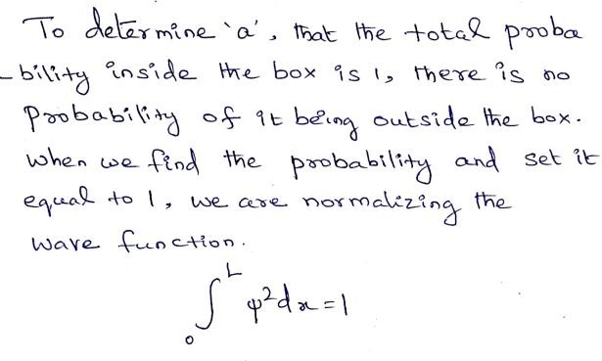

1. **What is the Heisenberg uncertainty principle?**

**Uncertainty principle**, also called **Heisenberg uncertainty principle** or indeterminacy **principle**, statement, articulated (1927) by the German physicist Werner **Heisenberg**, that the position and the velocity of an object cannot both be measured exactly, at the same time, even in theory.

∆X × ∆p ≥ h/4*πh*

Where,

∆X – uncertainty in position

∆p – uncertainty in momentum H – planck's constant

# Give the plots of radial wave functions for hydrogen atoms.

The solutions to Schrödinger's equation for atomic orbitals can be expressed in terms of spherical coordinates: r, θ, and ϕ. For a point (r,θ,ϕ), the variable r represents the distance from the center of the nucleus, θ represents the angle to the positive *z*-axis, and ϕ represents the angle to the positive *x*-axis in the *xy*-plane.

Because the atomic orbitals are described with a time-independent potential **V**, Schrödinger’s equation can be solved using the technique [of separation of variables](http://mathwiki.ucdavis.edu/Analysis/Ordinary_Differential_Equations/First_Order_Differential_Equations/Separable_Differential_Equations), so that any wavefunction has the form:

Ψ(r,θ,ϕ)=R(r)Y(θ,ϕ)

where R(r) is the **radial wave function** and Y(θ,ϕ) is the **angular wave function**: Y(θ,ϕ)= Φ (θ)Φ(ϕ)

Each set of quantum numbers, (n, l, ml), describes a different wave function.

# What is the significance of angular wave function?

The **angular wave function** describes the spherical harmonics of the electron's motion. Because orbitals are a cloud of the probability density of the electron, the square modulus of the **angular wave function** influences the direction and shape of the orbital.

# What is Linear Combination of Atomic Orbitals (LCAO)? Give the wave function equations for the formation of molecular orbitals by the combination of atomic orbitals?

The Linear combination of atomic orbitals which is also known as LCAO is an approximate method for representing molecular orbitals. It’s more of a superimposition method where constructive interference of two atomic wave functions produces a bonding molecular orbital whereas destructive interference produces non-bonding molecular orbital.

# Conditions to be satisfied:

The conditions that are required for a linear combination of atomic orbitals are as follows:

* **Same Energy of combining orbitals –** The combining atomic orbitals must have same or nearly same energy. This means that the 2p orbital of an atom can combine with another 2p orbital of another atom but 1s and 2p cannot combine as they have appreciable energy differences.
* **Same symmetry about the molecular axis –** The combining atoms should have same symmetry around the molecular axis for proper combination, otherwise, [the electron](https://byjus.com/chemistry/electrons/) density will be sparse.

For e.g. all the sub-orbitals of 2p have the same energy but still, the 2pz orbital of an atom can only combine with a 2pz orbital of another atom but cannot combine with 2px and 2py orbital as they have a different axis of symmetry.

In general, the z-axis is considered as the molecular axis of symmetry.

* **Proper Overlap between the atomic orbitals –** The two atomic orbitals will combine to form molecular orbital if the overlap is proper. Greater the extent of overlap of orbitals, greater will be the nuclear density between the nuclei of the two atoms.

# Differentiate bonding and antibonding molecular orbital.

|  |  |
| --- | --- |
| Bonding molecular orbital | Anti Bonding molecular orbital |
| Molecular orbitals formed by the additive effect of the atomic orbitals is called bonding molecular orbitals | Molecular orbitals formed by the subtractive effect of atomic is called anti-bonding molecular orbitals |
| Probability of finding the electrons is more in the case of bonding molecular orbitals | Probability of finding electrons is less in antibonding molecular orbitals. There is also a node between the anti-bonding molecular orbital between two nuclei where the electron density is zero. |
| These are formed by the combination of + and  + and – with – part of the electron waves | These are formed by the overlap of + with – part. |
| The electron density, in the bonding molecular orbital in the internuclear region, is high. As a result, the nuclei are shielded from each other and hence the repulsion is very less. | The electron density in the antibonding molecular orbital in the internuclear region is very low and so the nuclei are directly exposed to each other. Therefore the nuclei are less shielded from each other. |
| The bonding molecular orbitals are represented by σ, π, δ. | The corresponding anti-bonding molecular orbitals are represented by σ∗ , π∗, δ∗. |

1. **Give the differences between atomic and molecular orbitals.** Differences between atomic orbital and molecular orbital are as follows. **Atomic orbital:**

A region where there occurs a high probability of finding an electron in an atom is known as atomic orbital.

An electron cloud leads to the formation of atomic orbitals around the atom. Single nucleus affects the electron cloud.

Atomic orbitals are monocentric because they are found around a single nucleus.

# Molecular orbital:

A region where there is the highest probability of finding an electron in a molecule is known as molecular orbital.

When fusion of atomic orbitals that have nearly the same energy take place then it tends to the formation of molecular orbitals.

In molecular orbitals, two or more nuclei affect the electron cloud.

Since, molecular orbitals are found around different nuclei. Hence, they are polycentric.

# What is s-s orbital overlapping? Give examples.

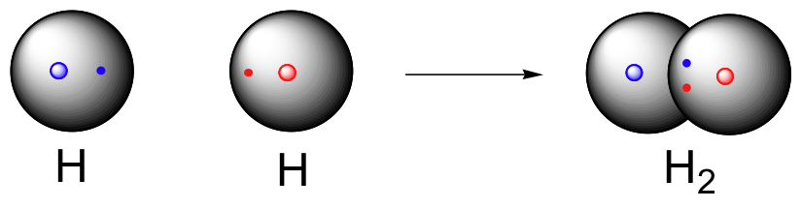When two half filled s - orbitals of two different atoms containing unpaired electrons with opposite spin overlap with each other it is called as s-s overlap.example, formation of Hydrogen molecule .

# Give the Molecular orbital diagram for Carbon Monoxide molecule {N.B: Only the diagram is required}and calculate its bond order.

Molecular Orbital diagram of Carbon monoxide molecule (CO): Total electrons:6+8 =14

CO =σ1s2,σ*1s2,σ2s2,σ*2s2, σ2px2, π2py2= π2pz2.

*Nb=10 Na=4*

*B.O =0.5 (Nb-Na) B.O=0.5(10-4) B.O= 3*

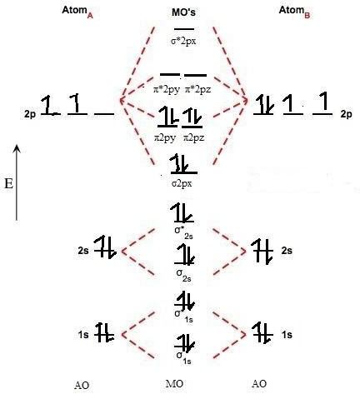

# Draw the shape of Molecular Orbitals obtained by overlap of s-p orbitals.

* To draw the shape of molecular orbitals obtained by overlapping of s and p orbital, the shape of the s orbital and p orbital must be drawn first.
* The ***'s' orbital*** is ***spherical*** and can hold a maximum of ***two electrons*** in it.
* On the other hand, '***p' orbital*** is ***in shape in which two circles are overlapping each other*** and it can hold a maximum of ***six electrons***.
* When these two orbitals overlap each other it leads to the formation of sigma bonding and gives structure in which both the 's' and 'p' orbitals joined together.
* The shape of s orbital, p orbital and molecular orbitals obtained by overlap are given in the

attachment.

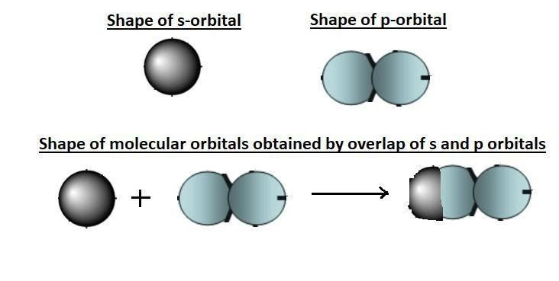

# What is p-p orbital overlapping? Give only the molecular orbital diagram taking an example.

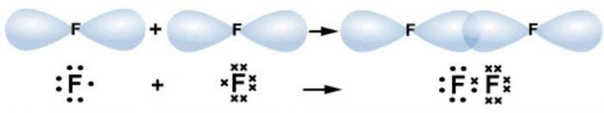The mutual **overlap** between two half-filled p-orbitals of two atoms is called **p-p overlap**. So the covalent bond formed is called a **p-p** bond. The formation of such a bond is also called axial **overlapping**. The two 'p' orbitals **overlap** each other when they acquire minimum potential energy.

# Give the type of overlapping that the following molecules undergo? i. H2 ii. O2 iii. HF

1. H2 – S-S Overlapping
2. O2 – S-P Overlapping
3. HF – S-P Overlapping

# Calculate the bond order for i. Hydrogen molecule ii. CO and iii. He

1. Hydrogen molecule – 1
2. Carbon monoxide – 3
3. Helium - 0

# Give a neat sketch on five d-orbitals.

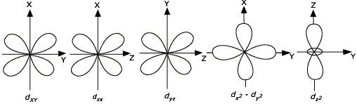

1. **Give the splitting pattern of d-orbitals in Oh complexes in the presence of ligands.**

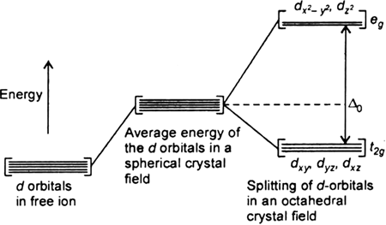

1. **What is CFSE? Give the formula for calculating it in Oh complexes.**

The **crystal field stabilization energy** (**CFSE**) is the stability that results from placing a transition metal ion in the **crystal field** generated by a set of ligands.

[Co(H2O) 2+] contains a d7 metal ion with a weak field ligand. This complex is known to be high spin from magnetic susceptibility measurements, which detect three unpaired electrons per molecule. Its orbital occupancy is (t2g)5(eg)2.

6

We can calculate the CFSE as -(5)(2/5)ΔO + (2)(3/5)ΔO = -4/5 ΔO.

# What is Huckel’s rule of aromaticity? Give an example.

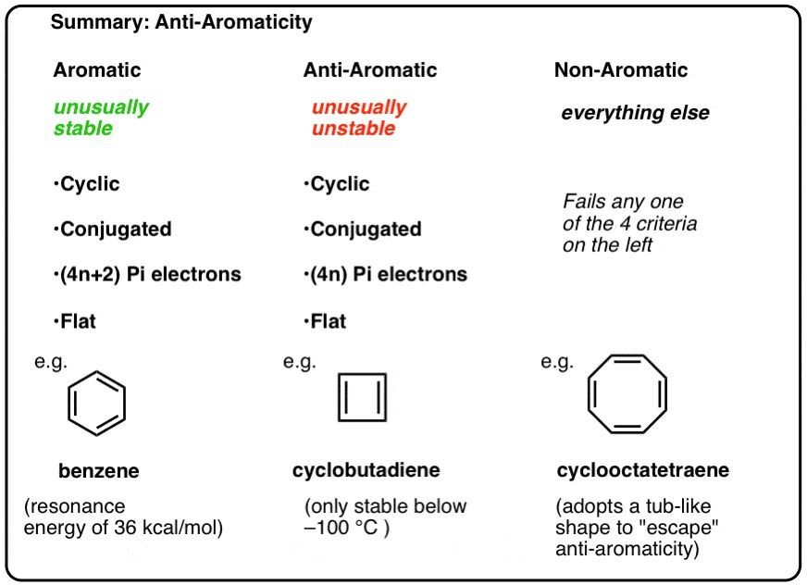According to **Huckel's rule**, all planar aromatic compounds must have [4n+2] pi-electrons where n is an integer (i.e. n= 0, 1, 2, 3, 4…etc.). This **rule** estimates whether a planar ring compound will possess aromatic properties or not.

# Compare Non-aromatic with Anti-aromatic compounds.

**Aromatic** molecules are cyclic, conjugated, have (4n+2) pi electrons, and are flat. **Antiaromatic** molecules are cyclic, conjugated, have (4n) pi electrons, and are flat. **Non**-**aromatic** molecules are every other molecule that fails one of these conditions.

AROMATIC VS ANTIAROHATIC VS

NONAROMATIC

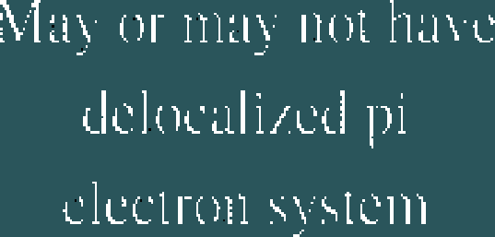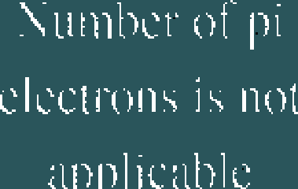

ttt)l11|J()tlllLlñ ‹t1L'

# What is HOMO and LUMO in Benzene?

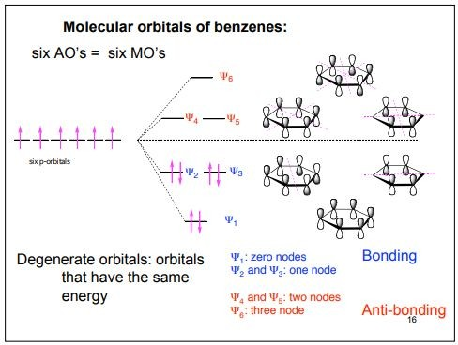

1. **What is HOMO and LUMO for 1,3-butadiene molecules?**

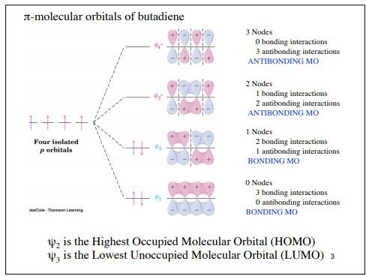

1. 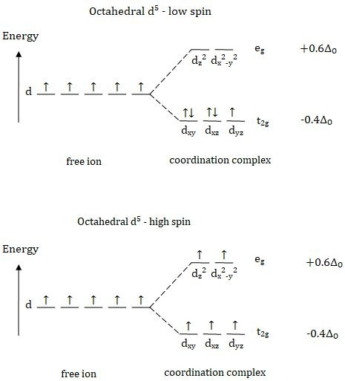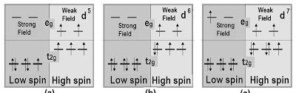**Calculate CFSE for high spin octahedral complexes having d5, d6 and d7 configurations.**
2. **What is meant by a nodal plane? Explain with an example.**

A **plane** passing through the nucleus on which the probability of finding electron is zero, is called a **nodal plane**. The number of **nodal planes** in an orbital is equal to azimuthal quantum number(l). Only option C has value l=1. Hence, **nodal plane** is found in L shell and p orbital.

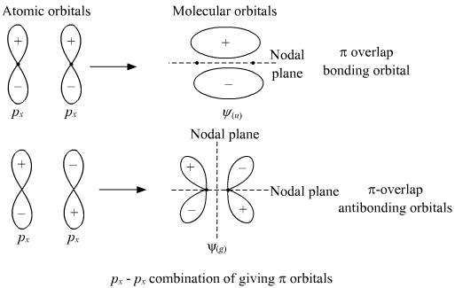

# Identify aromatic, non-aromatic and anti-aromatic compounds using Huckel’s rule from the following:

1. Anti aromatic
2. Aromatic
3. Non aromatic
4. Aromatic

# Based on Huckel’s rule, justify which of the following are aromatic, non aromatic and antiaromatic.

1. Non aromatic
2. Aromatic
3. Anti aromatic
4. Aromatic

# Calculate CFSE for [Fe(CN)6] 3- and [CoF6] 3- ions.

In [Fe(CN)6]4−, iron has 3d6,4s2 system in ground state but in excited state it loses two electrons in the formation of ions and two electrons from 4s, so thus Cobalt gets 3d6 configuration. Now it is of low spin complex due to CN ligands so all 6 electrons will go to t2g orbitals. and 0 electrons will be in eg orbital. By applying formula,

Δ = no. of electrons in t2g⋅(−0.4)+ no. of electrons in eg(0.6)

= 6(−0.4)+0(0.6)

= −2.4Δ0

In [CoF6]3−, cobalt has 3d7,4s2 system in ground state but in excited state it loses three electrons in the formation of ions and two electrons from 4s and one from 3d orbital so thus Cobalt gets 3d6 configuration. Now it is of high spin so 4 electrons go to t2g orbital and 2 electrons go to eg orbital. By applying formula,

Δ = no. of electrons in t2g⋅(−0.4)+ no. of electrons in eg(0.6)

= 4(−0.4)+2(0.6)

=−1.6+1.2

= −0.4 Δ0

1. Give any two factors that influence crystal field splitting in octahedral complexes.

The factors which influence the splitting in octahedral complexes are

* + the nature of the metal ion.
  + the metal's oxidation state. A higher oxidation state leads to a larger splitting relative to the spherical field.
  + the arrangement of the ligands around the metal ion.
  + the coordination number of the metal (i.e. tetrahedral, octahedral...)
  + the nature of the ligands surrounding the metal ion. The stronger the effect of the ligands then the greater the difference between the high and low energy *d* groups.

1. What is Pairing energy (P)? Give the relation between crystal field splitting in octahedral complexes (ΔO) and pairing energy (P).

Pairing energy, P, is the energy required to place two electrons in

the same orbital. If the crystal field splitting (Δ) is small because of weak-bonding ligands, then the pairing energy will be larger, and the complex will be high-spin. If the crystal field splitting (Δ) is large because of strong-bonding ligands, then the pairing energy will be smaller, and the complex will be low-spin.

1. Give the splitting pattern of d-orbitals in Td complexes in the presence of ligands.

In a tetrahedral crystal field splitting, the *d*-orbitals again split into two groups, with an energy difference of Δtet. The lower energy orbitals will be *d* 2 and *d* 2 2, and the higher energy orbitals will be *dxy*, *dxz* and *dyz* - opposite to the octahedral case.

*z x* -*y*

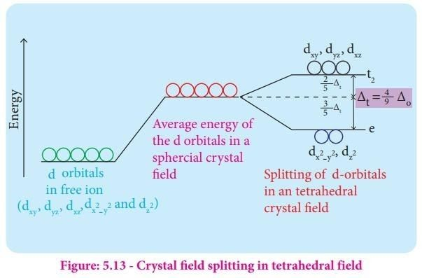

1. Give the formula for calculating CFSE in Td complexes.

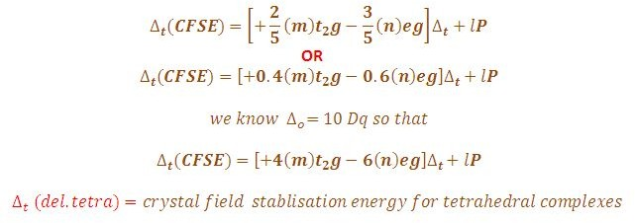

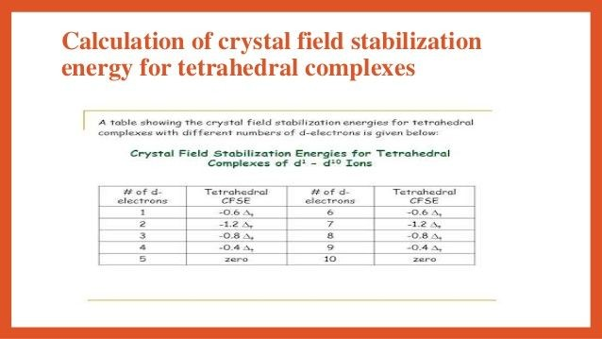

1. Why does TD geometry favours to form High spin rather low spin complexes?

In a tetrahedral complex, ΔtΔt is relatively small even with strong-field

ligands as there are fewer ligands to bond with. It is rare for the ΔtΔt of tetrahedral complexes to exceed the pairing energy. Usually, electrons will move up to higher energy orbitals rather than pairs. Because of this, *most tetrahedral complexes are high spin.*

1. What is a spectrochemical series? Mention its importance.

The spectrochemical series is a list of ligands (attachments to a metal ion) arranged in order of their field strength. The order of common ligands according to their increasing ligand field strength.

The ligands cyanide and CO are considered strong-field ligands and the halides are called weak-field ligands. Ligands such as water and ammonia are said to produce medium field effects.

1. Calculate CFSE for high spin Td complexes having d5 , d6 , d7 , and d8 configurations.



1. Calculate the magnetic moment value for the following complexes and predict whether paramagnetic or diamagnetic.
2. Low spin Oh complex with d7 and

t2g5 eg2 - paramagnetic

1. High spin Td complex with d4 configurations. eg4 t2g0 - diamagnetic
2. Classify the following as high spin or low spin complexes and calculate the magnetic moment of the complexes.
3. [CoF ]3-

6

t g4 eg2 - paramagnetic

2

1. [NiCl ]2-

4

eg2 t g2 - paramagnetic

2

1. [Fe(CN) ]3-

6

t g6 eg0 - diamagnetic

2

1. [CoCl ]2-

4

eg2 t g2 - paramagnetic

2

# ********